1. Creating and Renaming Files/Directories

Create a directory named test_dir using mkdir.

Inside test_dir, create an empty file called example.txt.

Rename example.txt to renamed_example.txt using mv

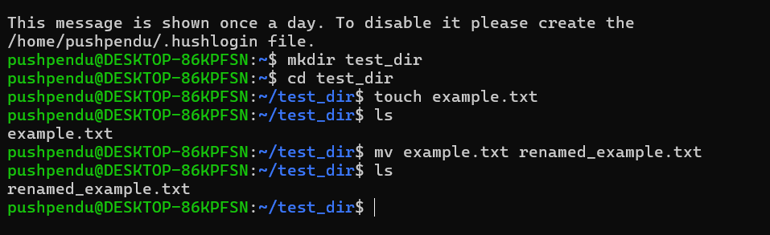

### **Explanation:**

* mkdir creates a new directory.
* touch creates an empty file.
* mv moves or renames a file.

2. Viewing File Contents

Use cat to display the contents of /etc/passwd.

Display only the first 5 lines of /etc/passwd using head.

Display only the last 5 lines of /etc/passwd using tail.

### **Explanation:**

* cat shows full contents.
* head -n 5 shows top 5 lines.
* tail -n 5 shows last 5 lines.

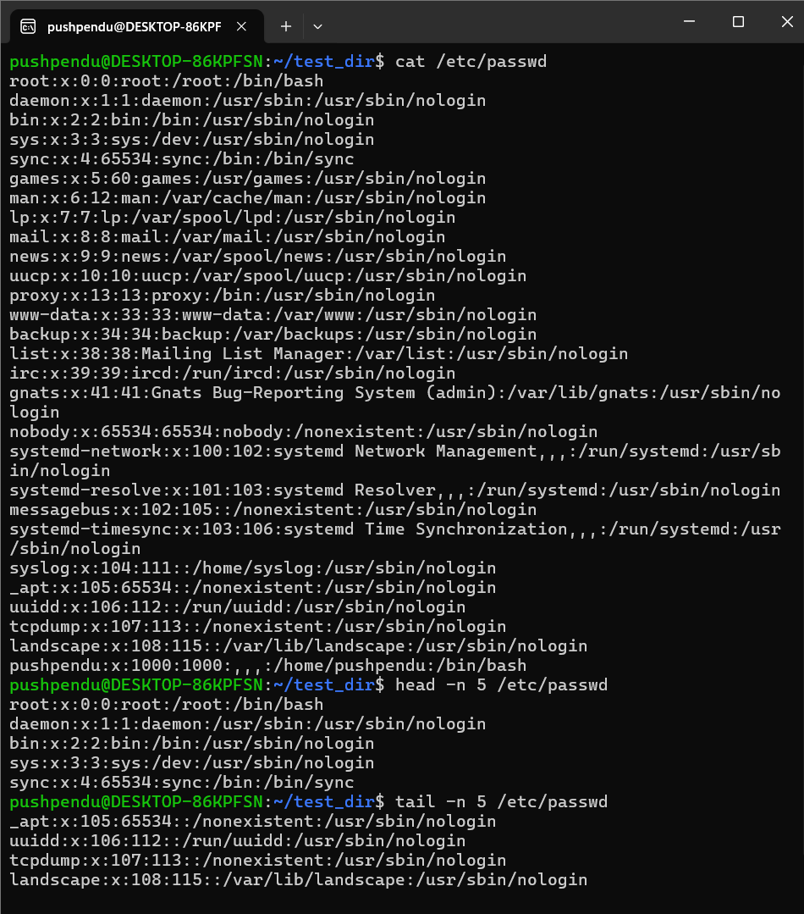

3.Searching for Patterns

Use grep to find all lines containing the word "root" in /etc/passwd.

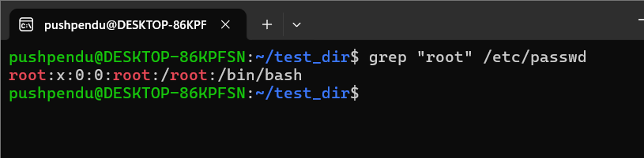

### **Explanation:**

* grep searches for lines containing **"root"** in /etc/passwd.

4. Zipping and Unzipping

Compress the test_dir directory into a file named test_dir.zip using zip.

Unzip test_dir.zip into a new directory named unzipped_dir.

### **Explanation:**

* zip -r recursively zips a directory.
* unzip -d extracts to a specific folder.

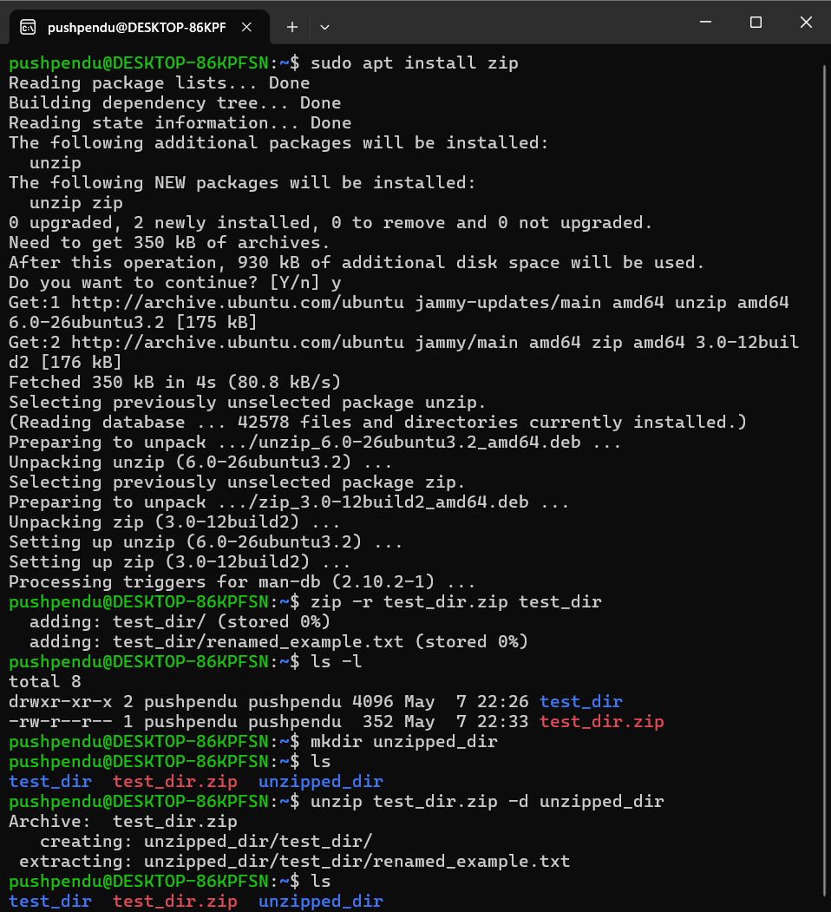

5. Downloading Files

Use wget to download a file from a URL (e.g., <https://example.com/sample.txt>).

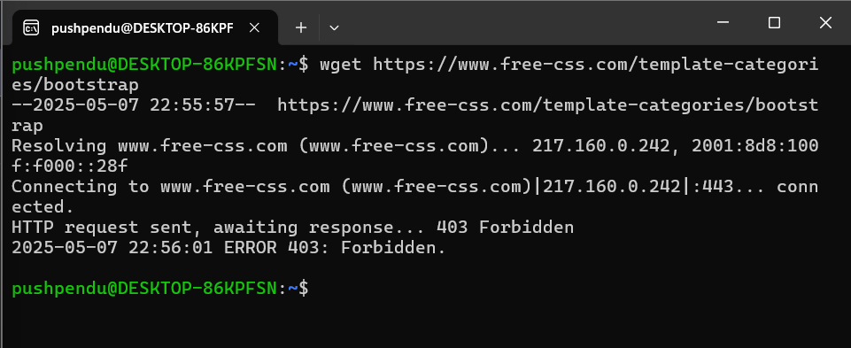

### **Explanation:**

* wget downloads files from URLs.

6. Changing Permissions

Create a file named secure.txt and change its permissions to read-only for everyone using chmod.

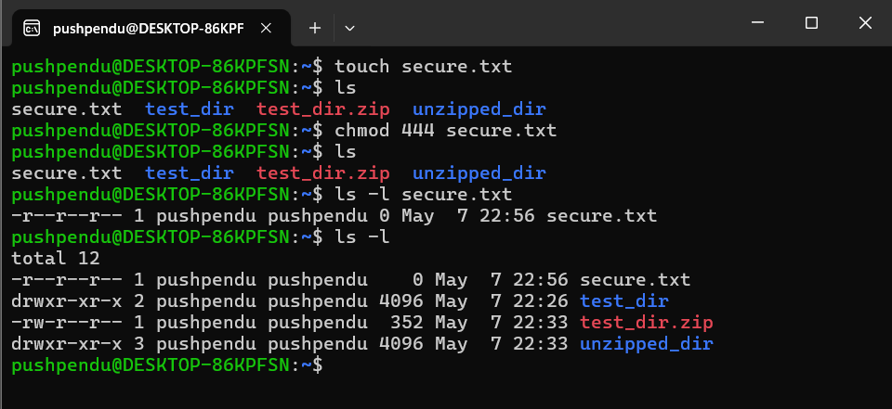

### **Explanation:**

* chmod 444 sets file permission to read-only for **owner, group, others**.

7. Working with Environment Variables

Use export to set a new environment variable called MY_VAR with the value "Hello, Linux!".

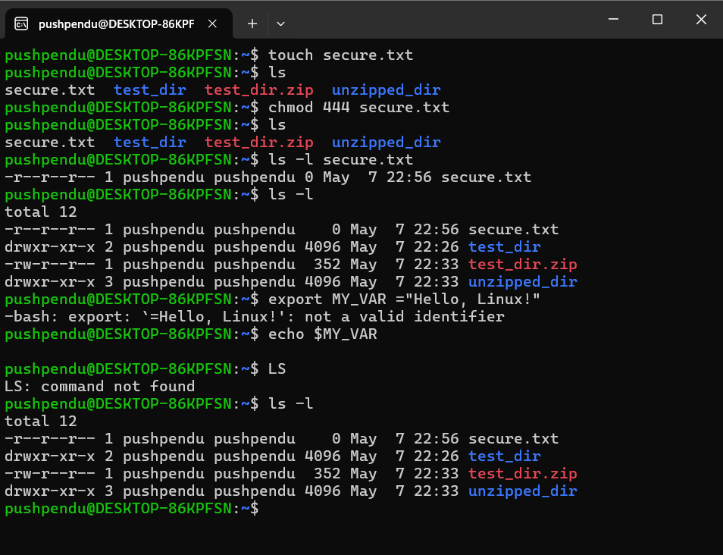

### **Explanation:**

* export sets an environment variable.
* echo prints its value.